Self-Reflective Report

Taliesin Murray

**Overview**

Throughout the duration of the year, many projects and their briefs have been set as exercises to improve certain skills in game design and development in order to further understanding of how games are crafted and produced. The three projects finalised and presented were The Voyager Project, The Kitchen Motion Utility Project and the Connect the Stars Project.

**Time Vs Outcome:** Through these projects, it has been highlighted how relationships between communication and time management have navigated how each project has progressed. For example, the time allocation for each project, as well as the amount of time between projects have created different outcomes. The complexity of the project too, affected the outcome. In the second project, the Kitchen Motion Utility Project, what was required was the creation of a gamified application, rather than a full functioning game; the more limited scope allowed for a project which was much more time-achievable.

This achievability is a contrast to the final project (Connect the Stars) which had greater time allocation, but more functions required for this more complex product. This complexity was compounded by the many different styles of code that were used to create a game with various functions built into it, and therefore, time was required to deal with bugs.

The projects can, likewise, be judged on the level of communication in each group, which impacted the quality of the project outcome: more complexity requires more structured communication. The impact of ineffective communication correlates to a poorer quality outcome. Furthermore, not working to team-member role strength (according to Belbin’s theories), presented projects which lacked cohesion, and effectiveness.

**Project 1: ‘The Voyage’**

**Initial Project Concepts and Considerations**

Beginning in the first semester of 2022, all students were given the brief to design a game which would demonstrate social and ecology awareness. A firm decision was made that this would be a product that would be for the educational sector consumption, and this, therefore, necessitated that the narrative of the game would have to be gender neutral and appropriate for young age ranges. In order to conform to these criteria, the main character was ungendered and simply known as ‘Blob’. To protect these characteristics, design inspiration was taken from the work of Roger Hargreeves, ‘Mr Men’ book and television series, as these characters would have been known by potential students, and therefore would present a familiarity ([Official Mr. Men & Little Miss Website (mrmen.com)](https://mrmen.com/)). Likewise, the further consideration of the ages of potential players highlighted their interest in, and understanding of, transportation modes ([Discovering Our Children's Interests | Psychology Today](https://www.psychologytoday.com/us/blog/great-kids-great-parents/201106/discovering-our-childrens-interests)). A variety of maps were considered, such as space and road vehicles. The designers on the team, however, chose to challenge themselves to create realistic water effects, and therefore the transportation needed to be nautical. It was speculated that further levels of the game could be set in different geographical and time locations.

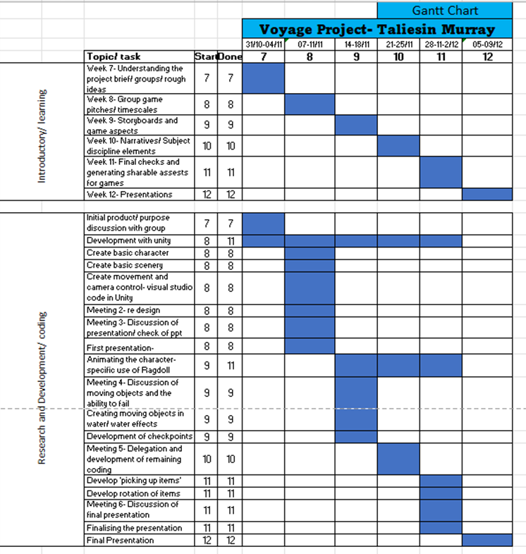

**Team Skills, Team Roles and Collaborative Practice**

Throughout these projects, the groups were assigned at random and generally composed of five to six members. The skills in each group were diverse, and not necessarily evenly distributed. The ‘Voyage’ project, for example, featured five students consisting of two 3D Computer Aided Design students, one Design student and two Game Developers. Unfortunately, the group did not have anyone with strong coding understanding. This was made apparent upon joining this group after being reallocated due to the insufficient number of members in the initial group. The difficulties of not having a proficient programmer became even more acute with the frequent and prolonged absences of the team member who was skilled in this area. As a Monitor Evaluator under the Belbin Teams Theory ([Team Asana](https://asana.com/resources/team-roles) 2021), being thrust into the role of Implementer, created challenges and necessitated extensive personal study to achieve any progress.

**Reflection Analysis**

Across the first project, ‘Voyage’, the general quality of the group work was fairly satisfactory, seeing as it was the first brief of the year and the group had no prior experience of what creating these pieces would be like; we worked well together despite the largely missing group member stunting the communication of the overall group somewhat.

The **planning** for the project was not fully realised, and, as such, the brief was still in development during its final submission, having a few issues in how the code and animations behaved together, but overall, for being a first product, the result was marginally better than originally anticipated. The **learning points** of this particular project were on how the game functioned and how to rotate particular items needed to be picked up, as well as the better understanding gained from creating a project with so many elements tied into one of movement, animation and items for a score. There were, therefore, many positives to the product.

As with any project, there were areas that presented **development opportunities** and improvements, such as being able to add the correct character model in and items needed for the aesthetics of the game, a difficulty with not having been sent any official 3d models for the pieces. Having said this, by using temporary models, it allowed experimentation of certain features such as general animation, an additional area which could have also been fixed to be implemented into the game. In the future, such examples will be revised and improved by collecting more resources and instructions on how to fully shape things into the wanted goal; in particular, the animations would be an example of something requiring essential improvement as it is a core feature that goes with a third person character movement. These could be corrected by revising relevant clips of tutorials and having a team member more familiar with code to help debug the program.

**The time management** for this particular project was fairly distributed and felt smooth in the way that most members of the group were actively participating in contributing to the work. Neither person in the group felt rushed or particularly worried over time, as the time was planned relatively strictly in a way that suited all members of the group.

The role of game developer in this particular brief was generally a supportive role, as a way to construct all work that had been done into one, with the knowledge of what was and was not doable to save any uncertainty or unnecessary redoing work.

The **research and future implications** in this project centred around how a character was meant to move and interact with the items in the environment, ranging from picking up items to how the player moved in relation to the surroundings. For this project, the research in how movement was used was particularly necessary in order to decipher the speeds between walking and running, how the idle animation is selected after a range of time as well as how items such as boats are used throughout the map to navigate a way it would make sense. The animations were a particular struggle to understand: using several sources frequently only disfigured the character’s 3D mesh. Using the Unity 3D website, as well as several YouTube videos, were not of extensive help, and the coding required a number of rewritings in order to fix the character from malfunctioning. Unfortunately, further research will be needed in the future since these skills will be essential for future projects.

**Project 2: The Kitchen Motion Utensils Project**

**Initial Project Concepts and Considerations**

The ‘Kitchen Motion Utensils’ project required a slightly different tempo of work, due to the fact it had a theoretical marketing design outcome rather than being a created product. In this particular product advertisement, the main focus was on creating an inbuilt feature of a knife that would encourage the user to cook more, encouraging healthy eating. Technically, this would be achieved by levelling-up through movement tracking. 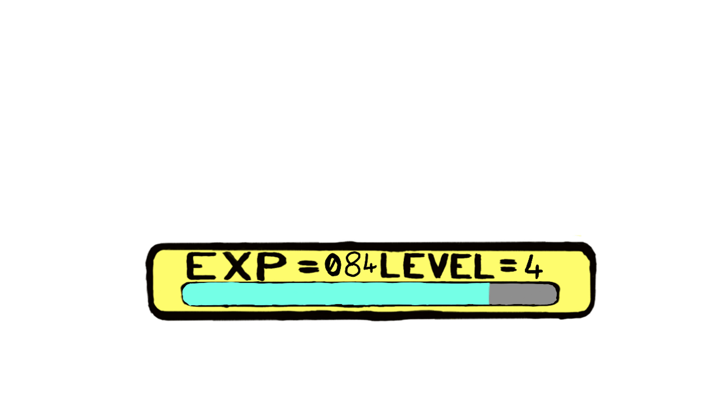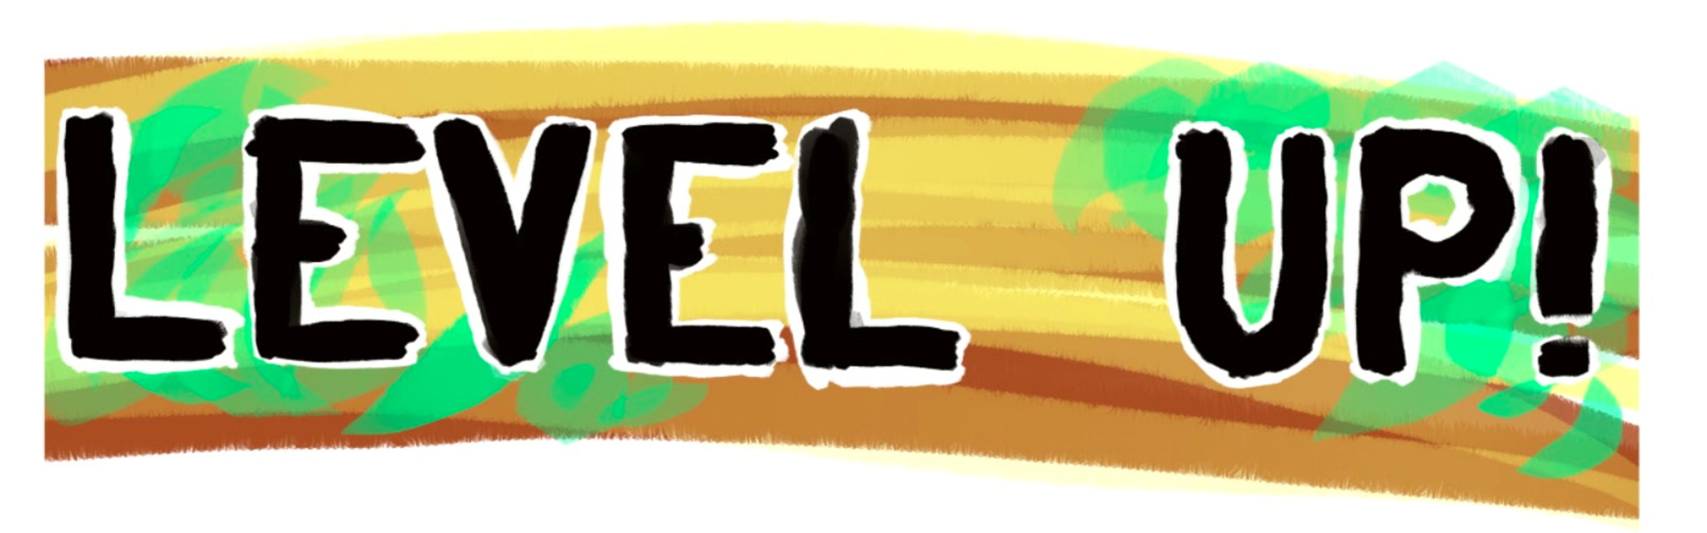

The main sections of **research** for this item was to decide an original **concept** that would be useful for a large range of people. This included the practicality of how it would entice the user to continue to use the object, in order to create healthy meals from fresh produce, rather than relying on over-processed and over-priced products. By using the product daily, consumers would gradually level up with exciting recipes and vouchers for new and exotic ingredients. This reward system would benefit the user so they would not only see their accomplishments from using the knife on the actual cooking utensil itself, but also using an app to help alert, remind and motivate the user, using press notifications, a bar representing the progress and the points won and a ‘friend’ option to compete with others in real life. This goal was to ultimately help develop a healthier lifestyle, selecting recipes for the user to try regarding personal preferences or allergies (Holinger, P 2011) The concept of also considering calorie intake was also discussed but otherwise dropped, so as to be mindful of customers who may have eating disorders or otherwise unhealthy eating patterns.

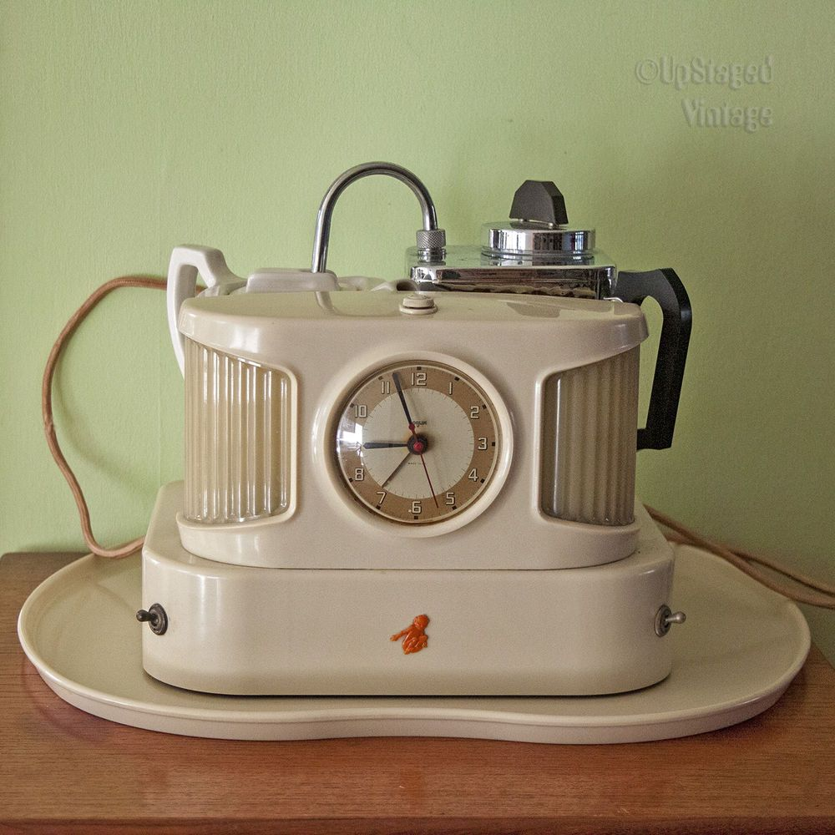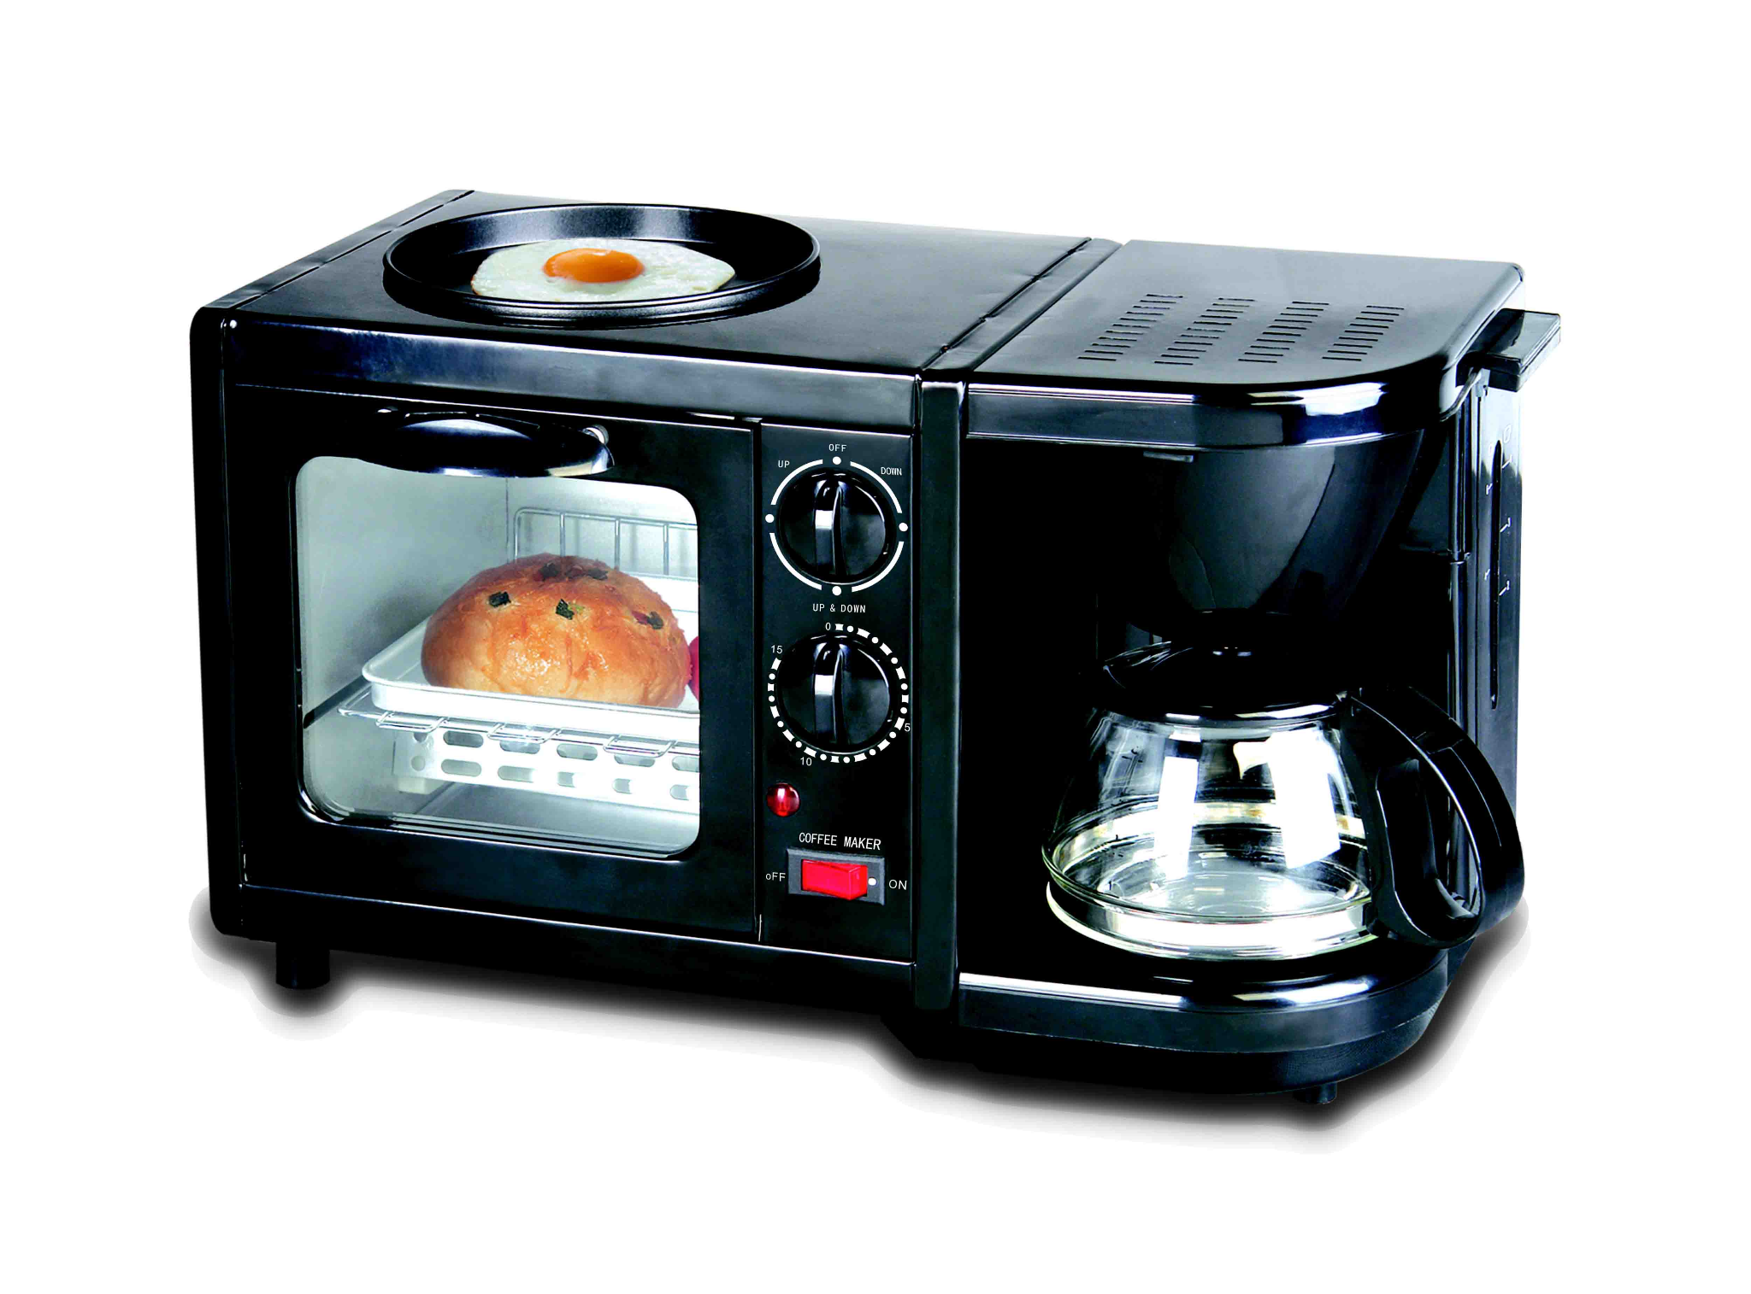

**Team Skills, Team Roles and Collaborative Practice**

The project originally started with a Team Coordinator(leader), but later, through several absences and general changes in attitude, it required the position to be taken over. This meant that while the project might have been progressing well at some stages, there were other points in time when the communication lacked cohesion and team members had to assume responsibilities for others. Particular team strengths were evident through independent member work as well as having the ability to adapt when plans would unpredictably change.

Individual focus, for me, within the group was as a Plant/ Specialist creating the levelling-up feature that would have been used for the item. Being a design consideration, it was quite straightforward.

**Reflection Analysis**

The project, in general, was successful but would improve with better team communication, especially in the presentation of the brief. The layout of the pitch was coherently initially: unfortunately, it was reworded and restructured by a team member in a way that lacked some clarity.

While the project was eventually successfully produced, the way that time had been distributed altered due to the wavering unpredictable plans in the absences of the group leader and roles of responsibility. For **future considerations**, this could be prevented possibly by having designated Co-ordinators and Monitor Evaluators automatically allocating portions of personal individual work in order to split time more wisely, increase personal responsibility, and prevent group stress if pieces by other members were not handed in.

**Project 3: The ‘Connect the Stars’ Interactive Learning Project**

**Initial Project Concepts and Considerations**

The ‘Connect the Stars’ interactive project was created to fit the brief of being educational while also making the experience of learning enjoyable through interaction with objects. This project in particular included a large smart board which would display a dot-to-dot picture you would have to solve in order to learn more about the constellation and solve a question about the solar system.

This project was aimed at a younger target audience and interactivity was achieved by the notion of a dot-to-dot game combined with a touch interactive nature of the touch screen of the smart board to give them a hands-on experience.

**Research**

As this was an educational project, consideration needed to be given to the individual cognitive learning style of each participant ([Teachable](https://teachable.com/blog/types-of-learning-styles)); and therefore, each scene should have been layered to address these. In future, and with additional time, specific learning styles could be incorporated. A clearer understanding of the coding processes would also speed up debugging.

For the program, main research that was considered was how the game functions worked in order to connect the points or to answer a correct question. Another area of development was to do with the background; an ‘infinite moving’ background would make it look more appealing to create the illusion of a larger area by simply looping the image as it scrolls past. This would have brought out the aesthetic of space and also given some additional interest to the game rather than having a simple static background. These areas were considered and development begun, but unfortunately they did not function on the day. Research sites included: (Comp-3Interactive 2020) /(Ghost Studios 2022)/ (Press Start 2019)/ (ProgrammingwithIzabel 2022)/ (Minkin 2023)/ (Brackeys 2018)/ (The Game Guy 2020- Multiple choice game)/ (The Game Guy 2020- Game Menu)/ (Can with code 2021)/ (Brackeys 2016)/ WatchFindDo Media (2019)

**Team Skills, Team Roles and Collaborative Practice**

Overall, the process of the game’s creation was challenging as there seemed to be additional research requirements that required more knowledge of functions such as manipulating a main menu screen. For me, as the game designer, the ability to create and code was somewhat unfocused and panicked. This was also compounded by the anxiety of having a future audience.

**Reflection Analysis**

The project had a number of challenges which mainly centred around the coding, leading to the unfortunate result of only the dot-to-dot feature working with no way of rewarding or correcting the user if they got it wrong. The structure of the game was organised in layers of the main menu screen: the level selection screen, the dot-to-dot game and the question about the solar system that would follow. Despite this organisation, an issue that repeatedly occurred was how, when the programme was run, the screen would display the incorrect section of the project, hiding the layer it was meant to be focused on but keeping that scene’s functions.

There was a 3D model of a satellite a designer in the group had constructed; the idea was for it to be animated around the screen in rotation, a feature that was heavily supported by the group but ultimately not executed due to time restraints. This can be said about many of the features in the game- that while there were several ideas and that most could have been possible, they generally did not get developed due to timing restraints.

Through all of this, the only working scene was the dot-to-dot game, and despite it not being finished, it proved to be a success during the official presentation. While the project wasn’t necessarily an overall success, it could be considered successful as it engaged a large age range of users and was surprisingly popular with players who wanted to test out the connecting dots mechanics.

In conclusion, through the second semester, the main points to focus on improving should be mostly in time management, slightly better communication with team members to ensure that everyone in the group is aware if something isn’t possible to complete within the time frame as well as making sure others were alright in producing their pieces of the project so they could be properly implemented in the game. Likewise, the focus should also be spent in fully researching the issues that occur in particular functions in order to properly dissect the errors in order to properly understand how they might work and how it can be solved if the function in practice goes wrong.

**Bibliography**

Brackeys (2016) [(108) How to make a Quiz Game in Unity (E02. CODE) - Tutorial - YouTube](https://www.youtube.com/watch?v=5CW1yGsVg4k&t=60s) accessed on 9 March 2023.

Brackeys (2018) [(108) TOUCH CONTROLS in Unity! - YouTube](https://www.youtube.com/watch?v=bp2PiFC9sSs) accessed on 9 March 2023.

Can with Code (2021) [(108) How To Make A Quiz Game Under A Minute With Multiple Choices! (Unity) - YouTube](https://www.youtube.com/watch?v=_YFegmzlcT8&t=1s) accessed on 9 March 2023.

Comp-3 interactive (2020) [(108) How to Make Looping Backgrounds [Unity Tutorial] - YouTube](https://www.youtube.com/watch?v=A5YSbgqr3sc), accessed on 9 March 2023.

Holinger, P (2011) [Discovering Our Children's Interests | Psychology Today](https://www.psychologytoday.com/us/blog/great-kids-great-parents/201106/discovering-our-childrens-interests) Accessed on 28/7/23.

Ghost Studios (2022) [(108) How to make Infinitely Repeating Background in UNITY! - YouTube](https://www.youtube.com/watch?v=ouUQOCtbJcs), accessed on 9 March 2023.

Minkin, Vladmir (2023) [(108) Unity - Puzzle - 2D - Connect Dots - YouTube](https://www.youtube.com/watch?v=U3iDD5f_K1s) accessed 9 March 2023.

[Official Mr. Men & Little Miss Website (mrmen.com)](https://mrmen.com/) Accessed on 28/7/23.

Press Start (2019) [(108) Scrolling Repeating Background in Unity - YouTube](https://www.youtube.com/watch?v=3UO-1suMbNc&t=1s), accessed 9 March 2023.

ProgrammingwithIzebel (2022) [(108) 1LINE One-stroke Puzzle Unity 2D Complete Project | Connect Dots | Part 1 - YouTube](https://www.youtube.com/watch?v=a3cs6ybxWdY), accessed 9 March 2023.

Teachable Staff, 7 Types of Learning Styles and how to teach them, [7 Types of Learning Styles and How To Teach Them - Teachable](https://teachable.com/blog/types-of-learning-styles)[C3](https://www.c3health.org/blog/food-consumption-trends-in-the-uk/)  Accessed on 28/7/23.

The Game Guy (2020) [(108) How to make a Quiz Game with Multiple Choices in Unity - YouTube](https://www.youtube.com/watch?v=G9QDFB2RQGA), accessed on 9 March 2023.

The Game Guy (2020) [(108) How to make an AWESOME fully INTERACTIVE Game Menu in UNITY - Everything you need to know. - YouTube](https://www.youtube.com/watch?v=pGxI8_GYfUY&t=2s), accessed on 9 March 2023.

Team Asana (2021) [Team Roles: 9 Types to Create a Balanced Team [2021] • Asana](https://asana.com/resources/team-roles) accessed on 28/7/23.

Vauterin, V (2022)[Collaborating for Health | Food consumption trends in the UK (c3health.org)](https://www.c3health.org/blog/food-consumption-trends-in-the-uk/) Accessed on 28/7/23.

WatchFindDo Media (2019) [(108) Unity Tutorial - How to create a Quiz Game [Part 1/7] - UI - YouTube](https://www.youtube.com/watch?v=HWCFJP6C4bk&t=1s) accessed on 9 March 2023.